White Paper

Streamlining Regulatory Licensing with Advanced Information Technology

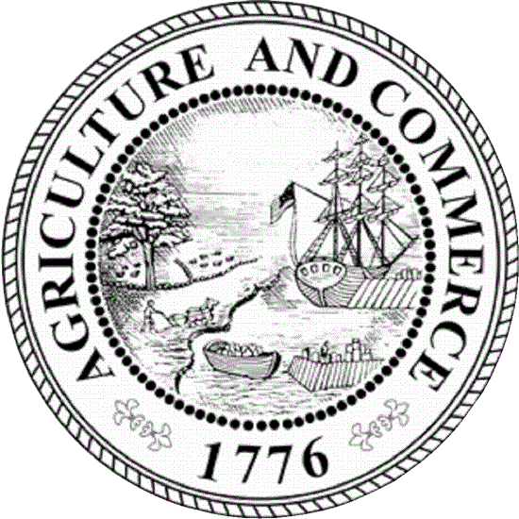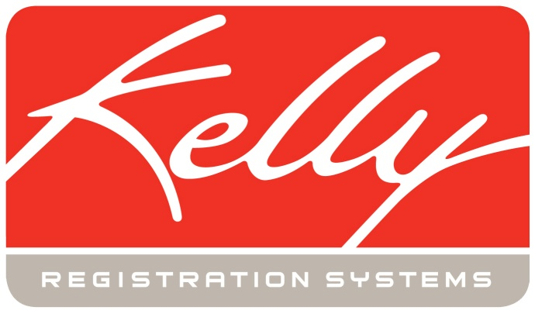

Streamlining Regulatory Licensing with Advanced Information Technology

Executive Summary

When he assumed office in 2011, newly elected Georgia Department of Agriculture (GDA) Commissioner Gary W. Black promised to “modernize and streamline” agency operations to align with new budget realities and expectations of government access. One change he came to view as imperative was the move to automate licensing processes.

Five separate regulatory divisions within the department were issuing licenses independently of each other, all with separate paper-based systems featuring multiple steps and processes – functional at their own paces, but far from efficient. With assistance from Georgia company Kelly Registration Systems, GDA was able to realize a swift and smooth transition from five paper-based systems to a single, advanced technology platform that makes it possible for all GDA license applications and renewals to be handled online, paperlessly.

Department of Agriculture Licensing Overview

GDA comprises five regulatory divisions: Animal Industry, Food Safety, Fuels and Measures, and Plant Industry and Marketing. These divisions historically performed inspections and issued more than 70 types of licenses separately to entities ranging from grocery stores to gas stations to pest control companies. By 2012, the total number of licenses and product registrations issued across all departments exceeded 130,000. Most licenses are renewed annually according to one of three dates: start of fiscal year, start of calendar year, or application anniversary date. As a result, the department processes a very high volume of transactions year-round.

The Impetus to Automate Licensing

Until 2013, a combination of licensing fees and tax revenues covered the operating cost of licensing. Changes to come under Commissioner Black’s leadership would include modernizing the management of data and funds related to the administration of these licenses, delivering greater transparency and service value.

At this same time, Georgia Code began requiring verification of citizenship/immigration status for all public benefits issued, including certifications, licenses, and registrations. To satisfy this requirement, all new license applications and annual renewals would need to be accompanied by a notarized affidavit and one form of acceptable identification as defined by law (including such government-issued IDs as passports, driver’s licenses, certificates of citizenship, or U.S. birth certificates).

Budget realities and the requirement to verify citizenship/immigration status made it clear that the old, decentralized system of paper-based processes was not sustainable. Commissioner Black took steps to consolidate the issuing of licenses from all of the department’s regulatory divisions into a single licensing division to better serve GDA customers. The new Licensing Division was to include a division director, an IT specialist, and seven licensing coordinators transferred from the Department’s Operation Divisions. It would also operate a professional call center for customer service, staffed by both permanent and temporary workers to enable staff increases and decreases commensurate with shifts in incoming call volume.

The first order of business was to identify the appropriate platform for implementing an online licensing system. GDA’s search quickly led it to Covington, Georgia-based Kelly Products. Kelly Products’ software division, Kelly Registration Systems provides multiple solutions for agribusiness information and automation – including Kelly State Administrative Management System (KSAMS) which was designed and developed specifically for state departments of agriculture to automate and manage any type of license or product registration.

Selected Automation Platform

KRS offers a variety of software solutions that deliver intelligence and automation to chemical companies and to government agricultural departments and related agencies. KRS offerings of interest to GDA included:

- KSAMS-pr, (Kelly State Administrative Management System – product registrations), which captures registration information electronically, stores it paperlessly for immediate retrieval whenever and wherever needed, and facilitates data sharing with other KRS solutions. KSAMS-pr would enable GDA to send out annual renewal notices, track payments by check or credit card, and otherwise manage every aspect of data related to registered products.

- KSAMS-bdi (Kelly State Administrative Management System – businesses, dealers and individuals) which similarly captures and stores licensing, permit and certification data electronically. KSAMS-bdi would make possible the replacement of more than 70 database/spreadsheets with a single software program that allows staff to manage any type of license data without sacrificing the business rules and unique data requirements of each license type.

Both solutions deliver automation on a hosted platform that requires no infrastructure investment while delivering accuracy, speed and immediate payment capture. Kelly Registration Systems also offers customization services, which were used in this project to create the various electronic forms needed for GDA licenses and to implement workflow automation, including the posting of payments directly to a financial institution.

The implementation project began in late 2012. GDA officially announced the verification of citizenship requirements to licensees on May 1, 2013 with an identified go-live date of July 1, a date that was successfully met. Going live with the new system enabled the Call Center to process secure and verifiable documentation and the new Licensing Division to manage the administrative side of issuing licenses, freeing the Operation Divisions to concentrate on the regulatory aspects of licensing.

Automation at Work

The main, immediate goal for KSAMS implementation was majority adoption by licensees for simplified license application, renewal processes, more customer-friendly, and efficient and transparent government – along with streamlined operations and compliance with Secure and Verifiable Documentation.

With the system now operational, new GDA licenses are issued when three actions occur in the Licensing Division system: 1) receipt of notification from an Operating Division that the license is approved, 2) receipt of payment for licensing fee, if applicable, and 3) receipt of the required verification of citizenship/immigration status. License renewals for the first renewal period are granted when any applicable fee is received along with verification of citizenship/immigration status; verifying documents are retained in the system and do not need to be resubmitted with subsequent renewals.

The system offers online credit/debit card and ACH payment options for fees, the method now preferred by a majority of licensees. When a business opts to pay an invoice by check, payment is accompanied by the invoice’s detachable coupon and mailed directly to the processing bank rather than going to the Department of Agriculture, as in the past. The bank issues daily electronic data on payments cleared, and that data is imported directly into KSAMS for automatic posting to license-holder records. To encourage the adoption of online payments, GDA absorbs all bank and credit card transaction processing fees.

[Sidebar:
Cafeteria style services accommodate business models
Businesses that have requirements for the same license at multiple locations can now pay for all locations’ licenses in a single transaction, replacing the old method of requiring each location’s license to be processed individually. Efficiencies with major customers benefit both government and its constituents.]

Rapidly Realized Operational Gains from Automated Licensing

Less than a year after implementation, GDA has already realized significant operational gains in terms of service delivery, efficiency, and cost savings.

- Service gains. The majority of license renewal notifications and certificates are now delivered by email rather than by U.S. Postal Service, with accompanying improvements in delivery accuracy – the previous paper-based system had an average delivery rejection rate of 20.5 percent; email delivery has reduced rejections to less than 1 percent.

By the end of December 2013, the new GDA system provided access to 74 types of licenses, simplifying customer interaction with GDA and making applications and renewals self-service for most customers. Customers who do need assistance have free access to the GDA call center for real-time assistance as needed, including assistance with completion of the required verification of citizenship/immigration status.

- Efficiency gains. Consolidating the GDA licensing function from five regulatory divisions to a single, centralized licensing division brought inherent gains in efficiency. The number of employees dedicated to license processing has been reduced from 23 employees to 7.

Even with fewer employees driving the process, automation has helped increase license issuance rates from approximately 20 licenses per day maximum to as many as 400. Cycle times in license processing have been reduced from weeks to hours – or even minutes.

- Financial gains. Automation has delivered even greater financial return on investment than was originally anticipated. Under the previous, paper-based system, printing and mailing license renewal notices and certificates of approval cost approximately $2.30 per license, a cost that has now been reduced to roughly $.70 per license – the license delivery mechanism alone has saved nearly a quarter-million dollars.

Approximately 140,000 transactions that formerly involved cash or check payments are now handled electronically, eliminating three manual processes per license transaction. Electronic processing also makes revenue available quicker, the security issues associated with cash and checks being held in GDA facilities have been eliminated. As well, formerly outstanding accounts are now current.

[Sidebar:
Using technology to change the way government thinks
Applying business-technology principles to government operation removes the negative connotations associated with “bureaucracy.”]

Benefits to Citizens and to State Government

The early-stage operational gains made by GDA’s move to automation have delivered tremendous benefits to the State of Georgia, its licensees, taxpayers, and the public.

- Taxpayers have immediately benefited by GDA’s collection of $10.8 million in licensing fees, which covers GDA licensing expenses.

- Licensees have a streamlined and convenient system with which to interact through online access as well as telephone access to a call center that handles up to 3,000 calls per week.

- The State of Georgia benefits financially in that cost reductions have more than made up for the cost of automation implementation. The system has paid for itself, requiring no long-term amortization.

- Finally, the citizens of Georgia across the board have benefited by the continuance of food safety and many other protections afforded by GDA licensing, even in the face of budget constraints.

Moving Forward

The gains realized from the automation of GDA licensing within its first year are just the beginning of gains under Commissioner Black’s vision for automation. Most GDA licensing is handled online today: The three-year goal is to move all licensing online through ongoing outreach and education. The Commissioner and IT team also look forward to investigating additional Kelly Registration Systems’ solutions that can help automate inspections and investigations to complement the assistance already provided in automated licensing.

About the GDA

The Georgia Department of Agriculture is the voice of the state’s agriculture community. The department's mission is to provide excellence in services and regulatory functions, to protect and promote agriculture and consumer interests, and to ensure an abundance of safe food and fiber for Georgia, the U.S., and the world by using state-of-the-art technology and a professional workforce. For more information, visit www.agr.georgia.gov.

About Kelly Registration Systems
A division of Kelly Products, Inc.

Kelly Registration Systems is a division of Kelly Products, Inc. Headquartered in Covington, Georgia, Kelly Products, Inc. provides various segments of the chemical and agribusiness industries with essential information and automation solutions. Kelly Products’ business units help leading chemical companies formulate and bring winning products to market quickly; assist departments of agriculture with electronic data capture, data tracking and funds collection for greater efficiency; and support gardening and landscaping interests by providing a wealth of information and assistance that fosters results for homes and businesses. For more information, visit www.kelly-products.com.

Kelly Registration Systems, Inc.
14481 Lochridge Blvd.
Covington, GA 30014
Phone: 770-385-0009
Fax: 770-385-0342

